5. Data

5.1 Which data we need
Searching online one of the most common used methods in value investing is analyzing financial filings and using stock price history. The reason for this is because they are very reliable and available. Publicly traded companies are required by law to share quarterly and yearly filings truthfully with the public.
Also they can be seen as an objective truth since a dataset containing financial reports like filings contains just numbers like revenue, profit, etc. The point is that any person who would have full access to the business and would analyze the business would eventually get the same numbers. Like mentioned before the U.S. companies accounting in financial reports is done by using the framework called GAAP which all filings have to be done in and is federally regulated and enforced by the SEC, which furthermore strengthens the reliability of the data.

5.2 Data requirements
Based on the expert interview, the stakeholder evaluates companies using a combination of financial data and qualitative judgement. For this project the focus is on the quantitative factors that can be represented in a dataset.
Quantitative Requirements (Suitable for Machine Learning)
Requirement | Reason
Historical stock prices | Required as the target variable and to measure how prices changed after financial reports became available.
P/E Ratio | Mentioned by the stakeholder as one of the valuation metrics used to assess whether a company appears expensive or cheap.
EV/EBITDA | Mentioned by the stakeholder as a commonly used valuation metric.
Revenue | Indicates the size and growth of the business.
Earnings / Net Income | Required to evaluate profitability and is used in valuation ratios such as P/E.
Book Value | Required for asset-based valuation methods and ratios such as P/B.
Dividend Information | The stakeholder mentioned dividends as an important indicator of shareholder returns and business quality.
Market Capitalization | Required to compare company size and identify potential differences between large caps and small caps.
Company Identifier and Date | Required to link financial data to the correct company and future stock price.
Also in accordance with the stakeholder interview all data should have multiple years of historical data, this is needed to observe how financial data affects the target variable stock price.
Qualitative Requirements (Less Suitable for Machine Learning)
Requirement | Reason
Management Quality | The stakeholder identified management as one of the most important factors, but it is difficult to measure objectively.
Business Quality | The stakeholder evaluates whether a business has a strong and sustainable business model, which is difficult to express numerically.
Competitive Advantage ("Moat") | Mentioned by the stakeholder as a key factor in valuation, but not directly available in financial datasets.
Market Sentiment | Influences stock prices but is not visible in financial statements.
Investor Psychology | Can create over- and undervaluation but is difficult to quantify reliably.
Strategic Decisions | Future decisions by management may significantly impact value but are not contained in historical financial data.
Because the qualitative requirements are difficult to measure and are not readily available in structured datasets, this project focuses primarily on the quantitative requirements.

5.3 Where do we get the data
As mentioned previously public traded companies are required to share truthful filings these are shared with S.E.C. (Security Exchange Comission). This is a federal goverment instance that overlooks all businesses. The S.E.C. manages a online registery freely available to the public containing all publicly traded companies filings at SEC.gov. SEC.gov offers a Edgar API which you can use to retrieve any financial data needed. However it gets returned as XRBL format and requires alot of formatting and parsing. Before being a usable dataset for a machine learning model. So I will keep this in mind for later.
Alternitavely Kaggle offers already cleaned up datasets of these same filings. If so this would reduce the need for cleaning up the data. So I can try and cross-examine and validate the Kaggle dataset with the one from S.E.C. to check for it’s accuracy. Financial filings is the exact type of dataset I’m looking for except it’s about Indian companies and I want to analyse European/US markets since the stakeholder mentioned in the expert interview this is where their main focus lies.
Another option is SimFin. It is a platform specialized in providing financial datasets such as, share prices, financial statements, ratios, etc. For the usage of quantitative algorithms it provides US and European markets. The financial sets are clearly structured and formatted also taking into account formatting making sure there’s no differences in data between businesses. Their dataset share price ratios seems very promising for my domain. Since in the stakeholder interview it was made clear that they use certain formulas to evaluate businesses, some of those formulas mentioned in the interview are also in this dataset. It’s also a rather large dataset with 22 million rows of share price history. And the rest of the ratios differ from a range between 11 and 16 million. The only problem is that this dataset is not free but I will explore this one.

5.5 How does the data look
List below are example images of the most recent anual filing from Apple with comments below, so the Kaggle and SimFin datasets are just collections from the SEC Edgar filings.
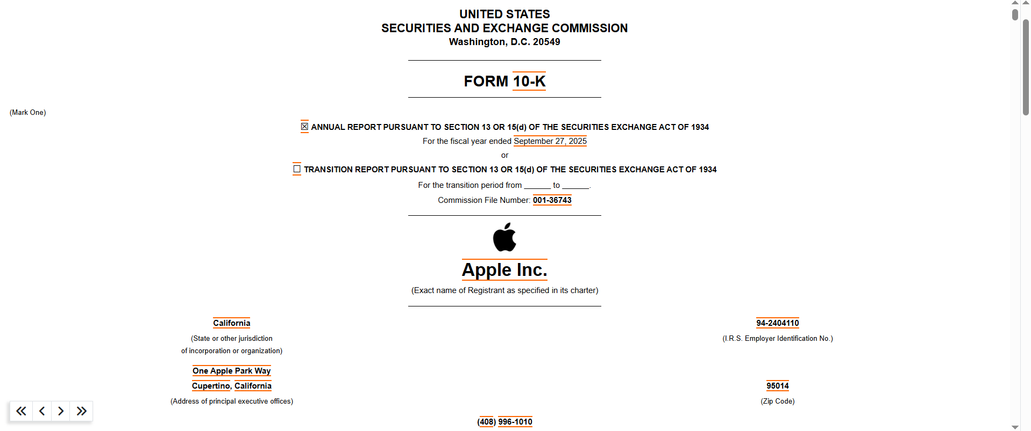
For example we can use a 10-K anual filing from Apple. That is available online as pdf or via an API by the Edgar database
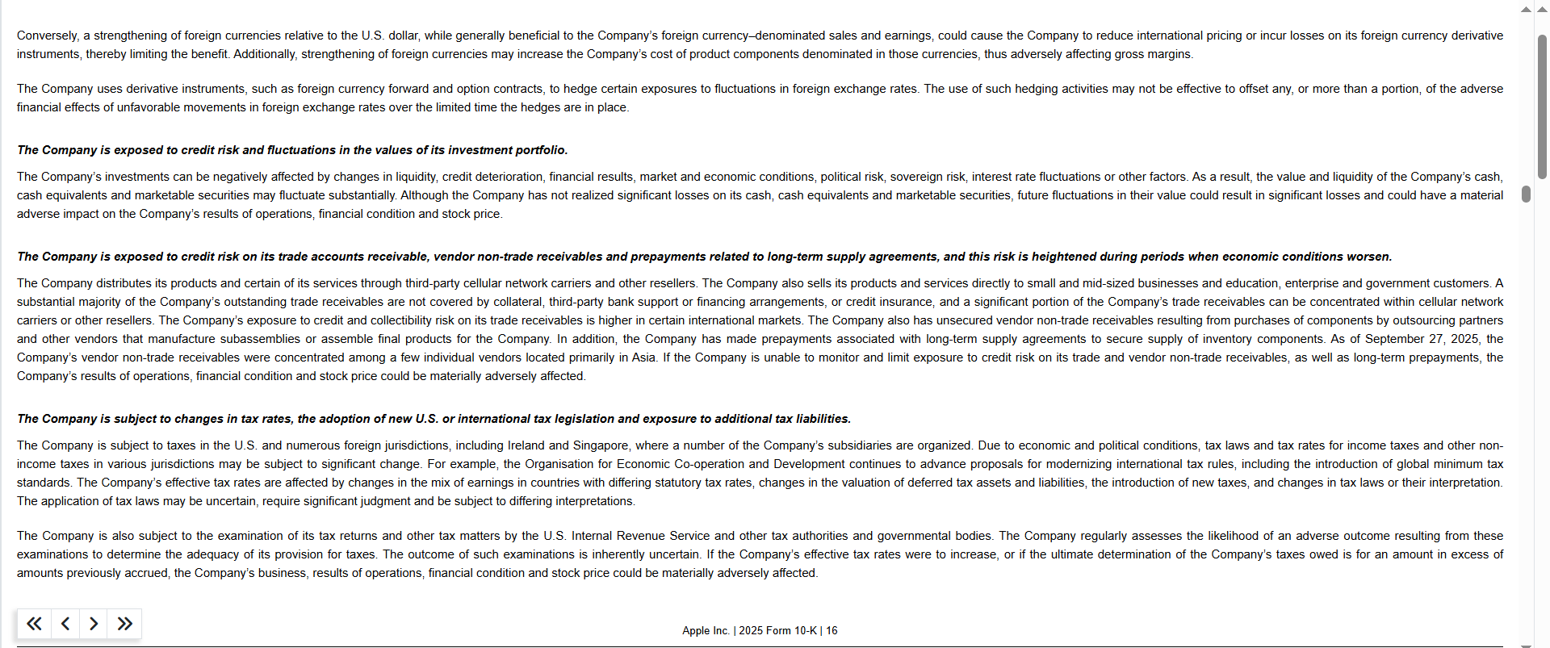
The S.E.C. filings also include textual disclaimers or announcements for investors to look at. For example management decisions or other important notes. An LLM might potentially be able to use these disclaimers for predictive analysis however I purposefully limit this outside the scope of this project or it would become to big.
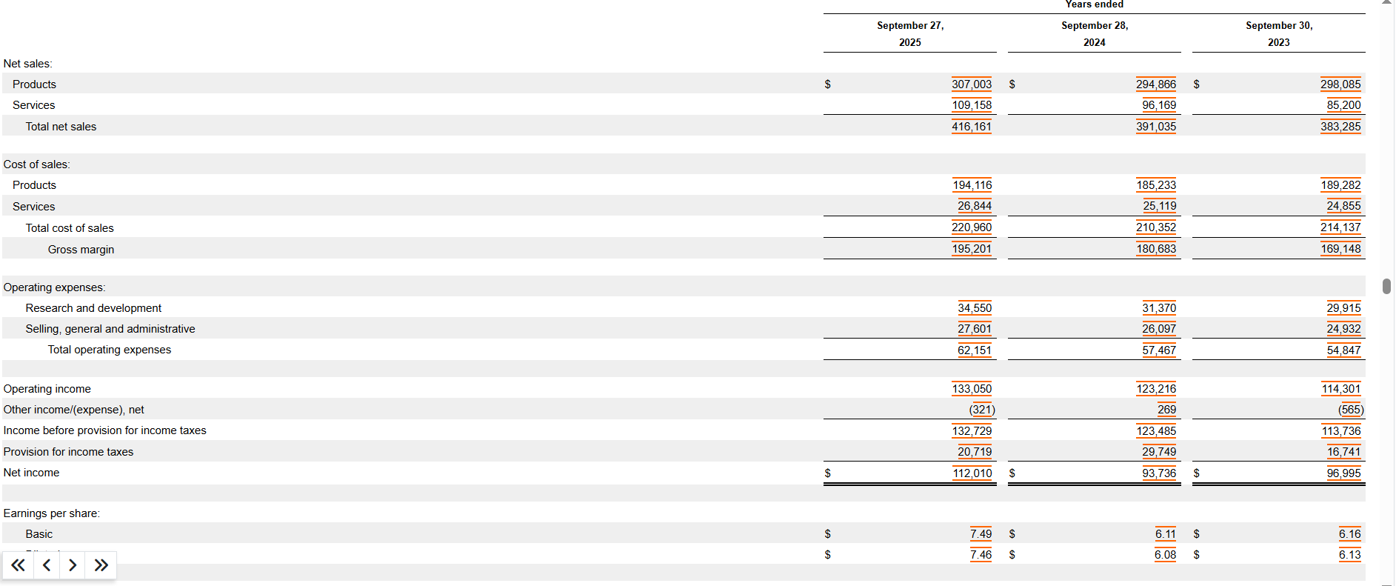
This is a small example of what the S.E.C. filings financial data statements look like
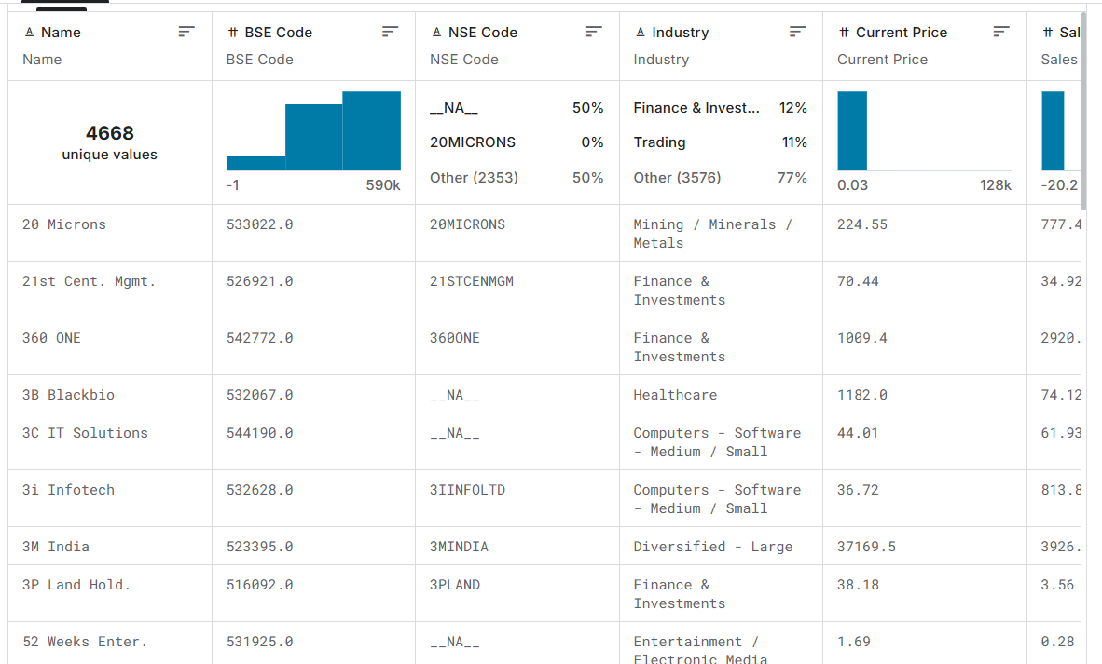
Here is the data transformed to a Kaggle dataset. It includes 58 attributes for each company. As well as bankrupt companies. Which could be useful to see if a model could predict this or even just to include it to prevent survivor ship bias, that the dataset only contains successful companies.
It spans multiple financial aspects, such as annual and quarterly profit and loss statements, balance sheets, cash flow data, financial ratios, and market prices. However the dataset is about Indian markets which isn’t the focus for the stakeholder.
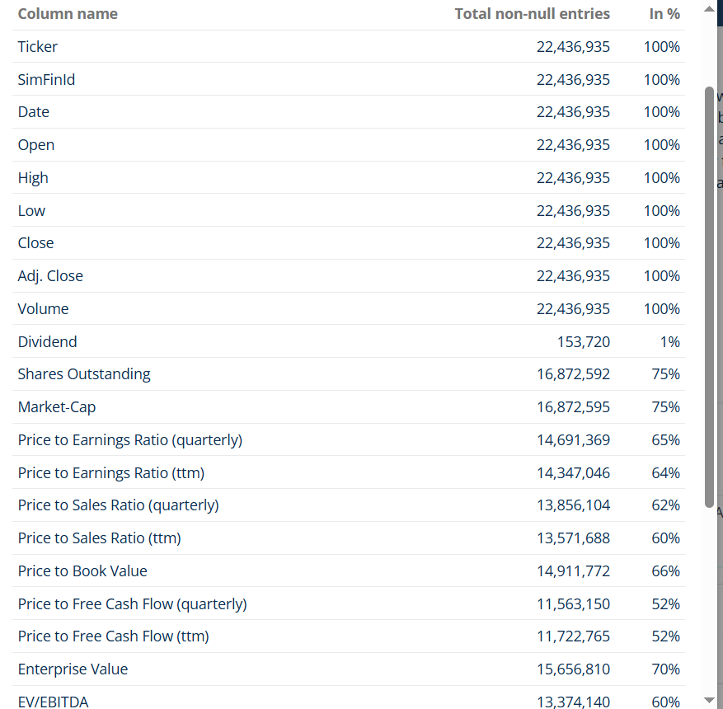
Here is a SimFin dataset derived of financial ratios. Including ratios mentioned by the stakeholder. The stakeholder mentioned for them they look at the stock price of a company. As well as other financial ratios derived from the filings which are also included in the dataset above and defined in the data requirements section.

Below is what the dataset from SimFin I might use for the initial model looks like containing these formulas and ratios:
Columns & Coverage
Please note: the coverage is mainly determined by the degree of how detailed the companies are reporting their financials.
Total columns: 28
Column name | Total non-null entries | In %
Ticker | 22,425,274 | 100%
SimFinId | 22,425,274 | 100%
Date | 22,425,274 | 100%
Open | 22,425,274 | 100%
High | 22,425,274 | 100%
Low | 22,425,274 | 100%
Close | 22,425,274 | 100%
Adj. Close | 22,425,274 | 100%
Volume | 22,425,274 | 100%
Dividend | 153,718 | 1%
Shares Outstanding | 16,859,493 | 75%
Market-Cap | 16,859,496 | 75%
Price to Earnings Ratio (quarterly) | 14,689,913 | 66%
Price to Earnings Ratio (ttm) | 14,347,489 | 64%
Price to Sales Ratio (quarterly) | 13,856,467 | 62%
Price to Sales Ratio (ttm) | 13,572,414 | 61%
Price to Book Value | 14,911,914 | 66%
Price to Free Cash Flow (quarterly) | 11,564,306 | 52%
Price to Free Cash Flow (ttm) | 11,724,712 | 52%
Enterprise Value | 15,645,790 | 70%
EV/EBITDA | 13,371,000 | 60%
EV/Sales | 13,558,629 | 60%
EV/FCF | 11,773,810 | 53%
Book to Market Value | 14,780,068 | 66%
Operating Income/EV | 14,374,898 | 64%
Altman Z Score | 11,483,836 | 51%
Dividend Yield | 7,309,209 | 33%
Price to Earnings Ratio (Adjusted) | 14,310,155 | 64%

One thing that should be noted that is clear is that there is a difference between available share price data which is 100% about 22 million rows. And financial ratios/formulas which ranges between 50% and 75% about 11 million to 16 million rows. So obviously in the model I’m gonna have to look where those missing values are. And what those missing values would mean for my model and how I want to handle them.

Based on the SimFin dataset containing most of my data requirements and also other features. As well as being a large range of dataset with historical data spanning 20 years this is the most qualified dataset and the one I will continue with.

5.4 Data Diversity
The selected dataset contains companies in different financial situations, ranging from small companies to large multinational corporations. It also covers multiple market conditions over approximately 20 years of historical observations. This diversity is important because it exposes the model to a wider range of financial scenarios during training.

